**ELEMENTS OF POWER SYSTEMS**

**EXPERIMENT 3**

**Codes:**

**1)**

clc

clear all

syms I1 I2 V R

P1=V*I1; %power supplied by 2-wire dc system

W1=2*I1^2*R; %power loss in 2- wire dc system

W1_per=W1/P1*100; %percentage power loss in 2- wire dc system

P2=sqrt(3)*V*I2; %power supplied by 3 phase 3 wire ac system

W2=3*I2^2*R; %power loss in 3 phase 3- wire ac system

W2_per=W2/P2*100; %percentage power loss in 3 phase 3- wire ac system

eq1= W1_per==W2_per;

I22=solve(eq1,I2);

P22=sqrt(3)*V*I22;

supply_load=((P22-P1)/P1)*100

**Output:**

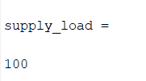

**2)**

clc

clear all

syms I1 I2 V R

P1=2*V*I1; %power supplied by 3 wire dc system

W1=2*I1^2*R; %power loss in 3- wire dc system

W1_per=W1/P1*100; %percentage power loss in 2- wire dc system

P2=3*V*I2; %power supplied by 3 phase 4 wire ac system

W2=3*I2^2*R; %power loss in 3 phase 4- wire ac system

W2_per=W2/P2*100; %percentage power loss in 3 phase 4- wire ac system

eq1= W1_per==W2_per;

I22=solve(eq1,I2);

P22=3*V*I22;

supply_load=((P22-P1)/P1)*100

**Output:**

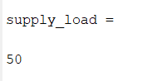

**3)**

clc

clear all

syms I1 I2 V R

P1=V*I1;%power supplied by 1 phase ac system

W1=2*I1^2*R; %power loss in 1 phase ac system

W1_per=W1/P1*100; %percentage power loss in 1 phase ac system

P2=sqrt(3)*V*I2; %power supplied by 3 phase 3 wire ac system

W2=3*I2^2*R; %power loss in 3 phase 3- wire ac system

W2_per=W2/P2*100; %percentage power loss in 3 phase 3- wire ac system

eq1= W1_per==W2_per;

I22=solve(eq1,I2);

P22=sqrt(3)*V*I22;

supply_load=((P22-P1)/P1)*100

p1=input("enter P1 value in kW: ");

p2_additional=((supply_load)/100 +1)*p1

**Output:**

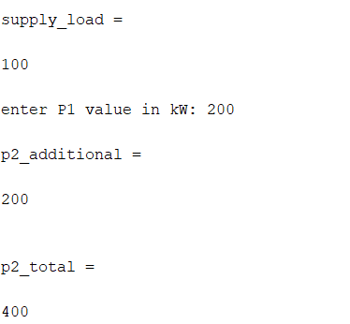

**COMBINED CODE:**

clc

clear all

%combined code for all three problems

a=input('enter\n 1 FOR CASE 1\n 2 FOR CASE 2\n 3 FOR CASE 3\n');

syms I1 I2 V R

if a==1

P1=V*I1; %power supplied by 2 wire dc system

W1=2*I1^2*R; %power loss in 2- wire dc system

W1_per=W1/P1*100; %percentage power loss in 2- wire dc system

P2=sqrt(3)*V*I2; %power supplied by 3 phase 3 wire ac system

W2=3*I2^2*R; %power loss in 3 phase 3- wire ac system

W2_per=W2/P2*100; %percentage power loss in 3 phase 3- wire ac system

eq1= W1_per==W2_per;

I22=solve(eq1,I2);

P22=sqrt(3)*V*I22;

supply_load=((P22-P1)/P1)*100

elseif a==2

P1=2*V*I1; %power supplied by 3 wire dc system

W1=2*I1^2*R; %power loss in 3- wire dc system

W1_per=W1/P1*100; %percentage power loss in 2- wire dc system

P2=3*V*I2; %power supplied by 3 phase 4 wire ac system

W2=3*I2^2*R; %power loss in 3 phase 4- wire ac system

W2_per=W2/P2*100; %percentage power loss in 3 phase 4- wire ac system

eq1= W1_per==W2_per;

I22=solve(eq1,I2);

P22=3*V*I22;

supply_load=((P22-P1)/P1)*100

elseif a==3

syms I1 I2 V R

P1=V*I1;%power supplied by 1 phase ac system

W1=2*I1^2*R; %power loss in 1 phase ac system

W1_per=W1/P1*100; %percentage power loss in 1 phase ac system

P2=sqrt(3)*V*I2; %power supplied by 3 phase 3 wire ac system

W2=3*I2^2*R; %power loss in 3 phase 3- wire ac system

W2_per=W2/P2*100; %percentage power loss in 3 phase 3- wire ac system

eq1= W1_per==W2_per;

I22=solve(eq1,I2);

P22=sqrt(3)*V*I22;

supply_load=((P22-P1)/P1)*100

p1=input("enter P1 value in kW: ");

p2_additional=((supply_load)/100)*p1

p2_total=((supply_load)/100 +1)*p1

end

**Output:**

